For demos a microphone ( like the GY MAX4466 breakout board) can be used. But for serious/daily use, a wired connection tied directly to the receiver is better. The wired connection needs to deliver an audio signal that's in the neighborhood of 1 to 2 Vp-p , and biased at ~1.6Vdc, to the Waveshare ‘sensor AD’ input.

Option A:

Converting from acoustic coupling to a wired connection can be as simple as two equal resistors and a capacitor:

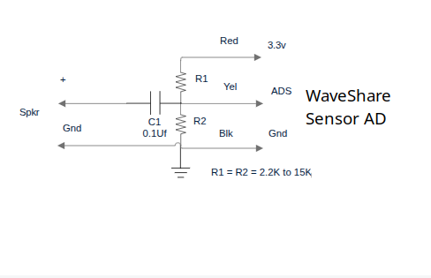

Option B:

A more versatile wired interface can be had using a GY MAX4466 modified, by removing the condenser mic, and the resistor, circled in yellow (See photo below). In the mic’s place, connect your interface cable, as indicated (+Audio & Ground) . This will give you a hardwired connection, with adjustable gain/volume (using the 'pot', just above the 'GND' & 'OUT' terminals)

Note:

Removing the resistor is NOT as hard as it might look/seem. If the tip of your soldering iron is wide enough, touch both sides to the resistor at the same time. It will come right off, with just a 'moments' worth of heat. De-soldering the mic takes working back and forth, between the two solder lands, along with some 'pulling' on the mic to 'walk' it out.

